VitaloQUB®

MODEL 9160

Instructions for Use

Rx Only

© Copyright Vitalograph 2025 Current Edition (Issue 5, 10-Apr-2025) Cat. No. 09650

**Vitalograph Branch Addresses:**

|  |  |
| --- | --- |
| A black and white rectangular sign with black letters  Description automatically generated Vitalograph Ltd, UK  Maids Moreton, Buckingham  MK18 1SW  England  Tel: 01280 827110  Email: sales@vitalograph.co.uk  www.vitalograph.com  Technical Support  Tel: 01280 827177  Email: technical.support@vitalograph.co.uk | Vitalograph (Ireland) Ltd  Gort Road Business Park  Ennis, Co Clare V95 HFT4  Ireland  Tel: +353 65 6864100  Fax: +353 65 6829289  E-mail: info@vitalograph.ie  www.vitalograph.com  Technical Support  Tel: +353 65 6864111  Email: technical.support@vitalograph.ie |
| A black and white logo  Description automatically generated Vitalograph GmbH  Rellinger Straße 64a  D-20257 Hamburg  Germany  Tel: +49 40 547391-0  Fax: +49 40 547391-40  Email: info@vitalograph.de  www.vitalograph.com  Technical Support  Telefon: +49 40 547391-14  Email: technical.support@vitalograph.de | Vitalograph Inc  13310 West 99th Street  Lenexa, Kansas, 66215  USA  Toll Free: 1-800 255 6626  Tel: (913) 730 3200  Email: contact@vitalograph.com  www.vitalograph.com  Technical Support  Tel: 1-800 255 6626  Email: technical.support@vitalograph.com |

© Copyright Vitalograph *2025*

Current Edition (Issue 5, 10-Apr-2025)

Cat. No. 09650

Vitalograph and VitaloQUB® are registered trademarks

Table of Contents

1. Intended Use/Indications for Use 4

2. Contraindications, Adverse Reactions, Warnings and Precautions. 4

2.1 Contraindications and Adverse Reactions 4

2.2 Warnings and Precautions 4

3. Main Components of the VitaloQUB 6

3.1 Features of the VitaloQUB: 7

4. Setting Up the VitaloQUB 8

5. Operating Instructions 13

5.1 Sensor Calibration 15

5.2 Cybersecurity Considerations 15

6. Power Management 16

6.1 Power Supply Information 16

7. Cleaning & Hygiene 16

7.1 Preventing Cross-Contamination of Subjects 16

7.2 Inspection of the Vitalograph VitaloQUB 16

8. Fault Finding Guide 17

8.1. Software Version Check 18

8.2. Product Useful Life Check 18

9. Customer Service 18

10. Consumables and Accessories 18

11. Disposal Instructions 19

12. Explanation of Symbols 19

13. Description of the VitaloQUB 20

14. Technical Specifications 21

15. Electromagnetic Compatibility (EMC) Standards 22

16. FDA Notice 24

17. Regulatory Information- EU Declaration of Conformity 25

18. Regulatory Information- UKCA 26

19. Guarantee 27

# Intended Use/Indications for Use

The Model 9160 Whole-Body Plethysmograph device, when used with the Vitalograph Model 9100, is designed for lung function testing on adults and pediatrics, 6 years and older, by trained medical healthcare professionals in a variety of professional healthcare environments e.g., primary care, hospitals, and pharmaceutical research centres.

The Model 9160 is a pulmonary function testing device which uses Morgan Scientific’s ComPAS2 software to measure subject respiratory parameters including FVC, SVC, MVV, CPF, RMS, SNIP, DLCO, MBN2, SBN2, Thoracic Gas Volume (TGV) and Airway Resistance (Raw).

# Contraindications, Adverse Reactions, Warnings and Precautions.

## Contraindications and Adverse Reactions

* + 1. **Contraindications**

The decision to conduct pulmonary function testing is determined by the ordering healthcare professional on the basis of their evaluation of the risks i.e., subject fatigue, and the benefits of pulmonary function testing for the particular patient. Caution should be used for patients prone to fatigue.

**2.1.2 Adverse Reactions**

Subject fatigue may occur during pulmonary function testing depending on the subject’s characteristics e.g., age, health status. For safety reasons, testing should be preferably done in the sitting position, using a chair with arms and without wheels. Subject may also take a break between tests.

## 2.2 Warnings and Precautions

1. No modification of this equipment is allowed. Any unauthorised changes to the VitaloQUB device may compromise product safety and/or data and as such Vitalograph cannot be held responsible and the device will no longer be supported.
2. The VitaloQUB device is not designed as sterile device. Always follow the safety guidelines given by the manufacturer of cleaning and disinfectant chemicals.
3. Vitalograph intends that a new Bacterial Viral Filter (BVFTM) be used for every subject to prevent cross contamination. Using a new BVF provides a significant level of protection of the subject, the device and the user against cross contamination during pulmonary function test manoeuvres. A BVF is for single use only.
4. Pulmonary function testing is a valuable tool that provides important information to clinicians which is used together with other physical findings, symptoms, and history to reach a diagnosis. Pulmonary function testing may support or exclude diagnosis, but it cannot make one.
5. When getting the VitaloQUB ready for use:
   1. Ensure that the paired device is setup correctly as per its relevant Instructions for Use (VitaloROV/ROV+ 09950) (VitaloLAB 09970).
   2. Ensure that the power supply is securely connected. Only use the VitaloQUB with the medically approved low voltage power supply with which it is supplied. Attempted use with other power sources may cause irreparable damage and invalidate the warranty. The output from the power supply is 24 volts DC.
   3. Ensure that the Patient Valve Bulkhead Connector is screwed on fully and the Heater Connector is connected to the underside of the Internal Enclosure inside the VitaloQUB device as per the instructions in Section 4. If either connector is not secure, test results may be inaccurate.
   4. Ensure that the Tubing Umbilical Bulkhead Connectors are screwed on fully and the Heater Connectors are connected to the underside of the External Control Module on the outside of the VitaloQUB and at the rear of the paired device as per the instructions in section 4. If either connector is not secure, test results may be inaccurate.

**Note: The VitaloQUB and its paired device need to be turned on to warm up for 20 minutes before testing proceeds.**

**Note: The paired device should not be positioned up against a wall for the following reasons: Ventilation fan inside the device may be restricted.**

1. The Patient Valve should be mounted on the Patient Valve Control Arm Holder, this will avoid the patient holding the Patient Valve by the Handle Grip and avoids putting their fingers into the openings where the Shutter Valve is located.
2. The VitaloQUB and its paired device should be powered off 5 minutes before disassembling the Patient Valve,to allow the internal Heater Assembly to cool down first.
3. Ensure that the Patient Valve tubing is not pinched or trapped when the Patient Valve is reassembled after accessing the Lilly Screen, as test results may be affected.
4. Take care not to block the mouthpiece with tongue or teeth during testing.
5. The following checks should be performed. If the device fails to pass these checks, the manufacturer or Service Agent specifically approved by Vitalograph should be contacted:
   1. All pulmonary function standards recommend checking the accuracy of lung function measuring devices daily with a 3 litre Precision Syringe to validate that the instrument is measuring accurately. The VitaloQUB should never be outside accuracy limits. Check accuracy after cleaning or disassembling the Patient Valve for any reason, after adjusting calibration, or if the Patient Valve has been dropped.
   2. A daily leak test and calibration must be performed to ensure the correct air tightness of the cabin and ensure test results are not affected.
6. Preventative inspection, maintenance and repairs should be carried out only by the manufacturer or by Service Agents specifically approved by Vitalograph.

**EN**

1. Maintenance must not be performed while the device is in use by a subject.
2. All values displayed are expressed as BTPS values.
3. Do not expose the VitaloQUB to liquids. The VitaloQUB is not designed to be waterproof.
4. The VitaloQUB should not be used in the presence of flammable liquids or gases, dust, and or any other chemical substances.
5. To isolate the VitaloQUB device from the mains supply, turn off the Main Power Switch on the underside of the External Control Module and remove the Power Supply from the mains wall socket. Also turn off the main Power Switch on the paired device and remove the Power Supply from the mains wall socket.
6. Do not position the device so that the Main Power Switch is inaccessible, or that the Power Supply is difficult to unplug from the socket.
7. Use of accessories and cables other than those specified or provided by Vitalograph for this equipment could result in increased electromagnetic emissions or decreased electromagnetic immunity of the VitaloQUB and result in improper operation. Only equipment that has been specified in Section 10 as compatible for use with the system shall be used.
8. Non-medical equipment must be kept outside the subject environment i.e. any area in which intentional or unintentional contact between the subject and parts of the system, or some other persons touching part of the system, can occur.
9. Portable RF communications equipment (including peripherals such as antenna cables and external antennas) should be used no closer than 30 cm (12 inches) to any part of the VitaloQUB or its paired device, including cables specified by Vitalograph. Otherwise, degradation of the performance of this equipment could result.
10. Use of this equipment adjacent to or stacked with other equipment should be avoided because it could result in improper operation. If such use is necessary, this equipment and the other equipment should be observed to verify that they are operating normally. The applied part is the Patient Valve. This along with the BVF, are the contact points for the subject during a pulmonary function test session. There are no adverse effects if the subject comes into contact with any other parts of the VitaloQUB device.
11. Ensure that the user does not simultaneously touch the patient and any output connectors (USB ports, HDMI ports, DC Power Connector port, power supply socket or Heater Connector) on the VitaloQUB device.
12. Only use the listed accessories/equipment specified in the Consumables and Accessory section or provided by Vitalograph for this equipment.
13. Avoid exposure to known sources of EMI (electromagnetic interference) such as diathermy, lithotripsy, electrocautery, RFID (Radio Frequency Identification), and electromagnetic security systems such as anti-theft/ electronic article surveillance systems, metal detectors. Note that the presence of RFID devices may not be obvious. If such interference is suspected, reposition the equipment if possible, to maximize distances.
14. If storing the device, ensure that is kept in a dry & ventilated environment.
15. Caution: Federal Law restricts this device to sale by, or on the order of a physician.

# Main Components of the VitaloQUB

The main components are shown below:

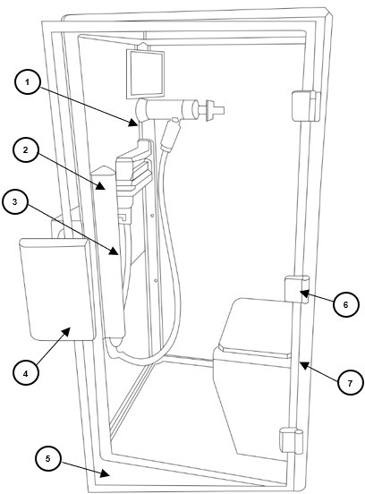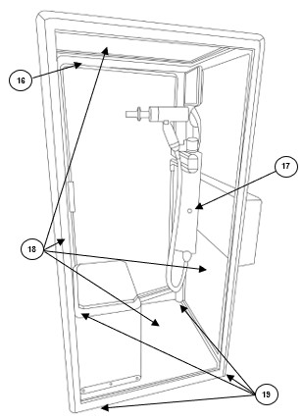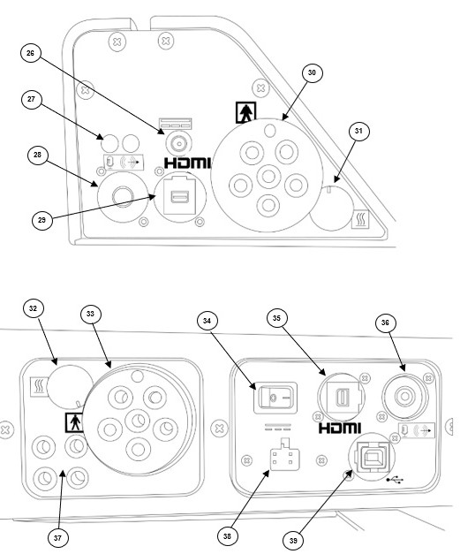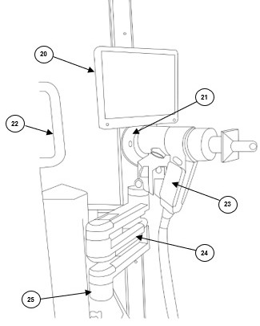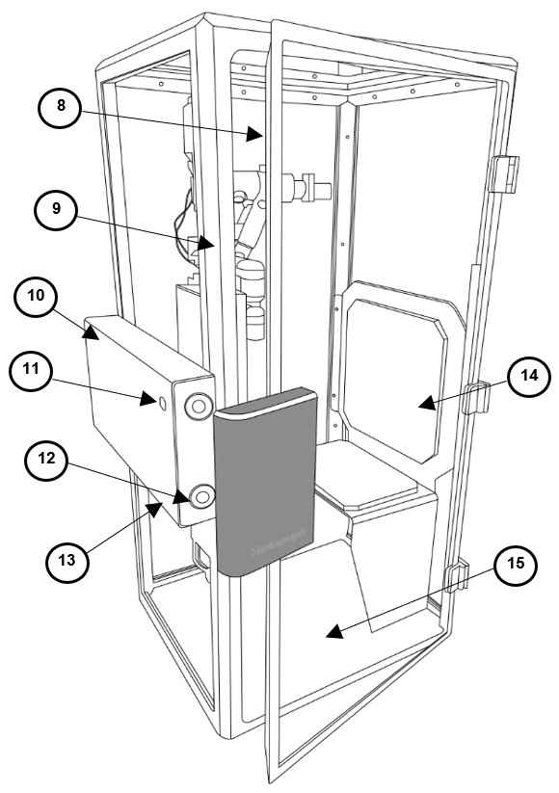

|  |  |
| --- | --- |
| 1 | Monitor Bracket |
| 2 | Internal Enclosure |
| 3 | Control Arm Vertical Positioning Mechanism |
| 4 | Door Handle |
| 5 | Glass Door |
| 6 | Hinges x3 |
| 7 | Door Seal Border Trim |
| 8 | Door Seal |
| 9 | Main Frame |
| 10 | External Control Module |
| 11 | External Door Release Button |
| 12 | Electromagnets |
| 13 | Power LED |
| 14 | Bench |
| 15 | Vinyl Floor |
| 16 | Internal Frame |
| 17 | Internal Door Release Button |
| 18 | Acrylic Panels x4 |
| 19 | Height Adjustable Feet (Underneath Frame) |
| 20 | Monitor |
| 21 | Dual Way Intercom Speaker System |
| 22 | Patient Support Grab Handle |
| 23 | Patient Valve Holder |
| 24 | Patient Valve Control Arm |
| 25 | Patient Valve Control Arm Holder |
| 26 | DC Power Connector - Monitor |
| 27 | Tube Connector - Box Pressure |
| 28 | Auxiliary Connection - Int |
| 29 | HDMI Port Connection - Int |
| 30 | Bulkhead Connector – Patient Valve |
| 31 | Heater –Patient Valve |
| 32 | Heater - Umbilical |
| 33 | Bulkhead Connector – Umbilical |
| 34 | On/Off Power Switch |
| 35 | HDMI Port Connection - Ext |
| 36 | Auxiliary Connection - Ext |
| 37 | Tube Connector Ports |
| 38 | Power Supply Connection |
| 39 | USB Comms Port |

## 3.1 Features of the VitaloQUB:

The VitaloLAB features include:

The features include:

* VTG & Airway Resistance testing
* 12” White Internal Display Monitor for patient viewing
* Dual-way intercom/speaker system for clinician & patient interaction
* Height adjustable Patient Valve Arm with various axes of rotation
* Seating Bench – 250 kg weight capacity
* Large clear viewing panels
* Height adjustable feet
* Non-slip floor
* Low entry step – Approx:60mm
* Internal Grab Handle for patient support

**EN**

* External Control Module
* Magnetic door lock/release system
* Door release feature (Int/Ext)
* ComPAS2 software
* Pairs with both VitaloROV/ROV+ and VitaloLAB devices
* Interchangeable Patient Valve as used in the VitaloROV/ROV+ and VitaloLAB

# Setting Up the VitaloQUB

**Note:** This device can only be used in conjunction with the VitaloROV/ROV+ device or the VitaloLAB device and must be setup by approved Vitalograph technicians.

To get the VitaloQUB ready for use:

1. For complete instructions on removing the device from its crate and getting device to its final location please refer

to the VitaloQUB Service Manual Installation Instructions (PN:07881) Appendix A at the end of the document.

1. Ensure two people are used during unpacking and setup.
2. Firstly, remove all the retaining clips from the shipping crate using a lever type screwdriver or similar and remove all timber panels. Ensure panels are supported when removing these clips to avoid the panels falling when clips are removed.

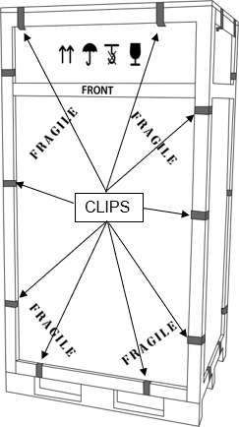

*Figure 2- VitaloQUB Shipping Crate*

1. Remove the VitaloQUB device from the shipping crate using an appropriate pallet truck/hand cart, ensuring that the pallet truck/hand cart does not slide backwards during this operation. Use appropriate straps to secure the device.
2. Fit the supplied height adjustable feet x4 (19) to the underside of the device.
3. Bring the VitaloQUB to its correct location and gently remove the VitaloQUB from the appropriate pallet truck/hand cart avoiding any sudden impacts.
4. Check that the VitaloQUB device is level on the ground using an appropriate spirit level. Using the adjustable feet underneath the VitaloQUB, adjust these feet appropriately to ensure the device is level.
5. Ensure the device is positioned so that the door of the VitaloQUB can open fully and ensure it is positioned so that the paired device can be connected to it with ease and operated without any restrictions.
6. Remove Patient Valve Control Arm from the Accessories Box (Figure 10) which is located under the seat inside the unit and attach the Patient Valve Control Arm (24) to the Patient Valve Control Arm Holder (25) using the supplied attachment on the Patient Valve Control Arm (24). Four M5 screws are used to secure the arm in place.

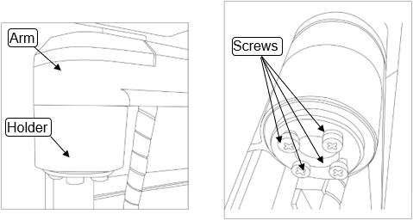

*Figure 3- Patient Valve Control Arm Holder*

1. Attach the Monitor Bracket (1) from Accessories Box to the Patient Valve Control Arm (24) using the supplied attachment screw on the Patient Valve Control Arm (24). The 12” Monitor (20) and Speaker from the Intercom System (21) are pre-assembled to the Monitor Bracket (1).

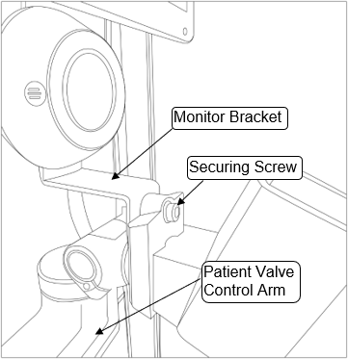

*Figure 4- Monitor Bracket Attachment to Patient Valve Control Arm*

1. Attach the Patient Valve Holder (23) from Accessories Box to the Patient Valve Control Arm

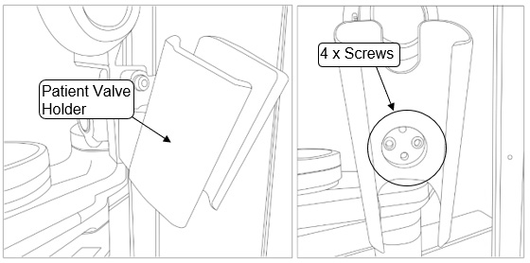Holder (25) using the four M5 bolts supplied. See figure 5 below:

*Figure 5- Patient Valve Control Arm Holder*

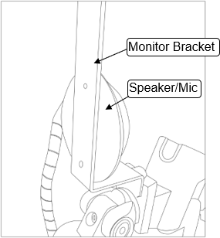

*Figure 6- Speaker/Mic mounted to Monitor Bracket*

1. Connect the DC Power Cable to the back of the Monitor (20) and then connect the other end to item 26 (figure 1) on the underside of the Internal Enclosure (2). This cable is pre-assembled to the Patient Valve Control Arm (24).
2. Connect the HDMI Cable to the back of the Monitor (20) and then connect the other end to item 29 (figure 1) on the underside of the Internal Enclosure (2). This cable is pre-assembled to the Patient Valve Control Arm (24).
3. Connect the cable of the Speaker/Mic from the Intercom System (21) to the sound jack port to item 28 (figure 1) on the underside of the Internal Enclosure (2).

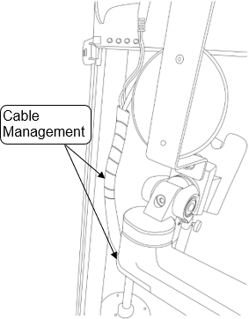

*Figure 7- Cable Management on Patient Valve Control Arm*

1. Connect the Patient Valve to the underside of the Internal Enclosure (2) by attaching the Bulkhead Connector to item 30 (figure 1) and place the handheld part of the Patient Valve in the Patient Valve holder (23). As in Figure 8, ensure that Bulkhead Connector alignment key is aligned correctly to the connector on the underside of the Internal Enclosure (2). The Bulkhead Connector must be screwed on fully to ensure a leak-tight fit.

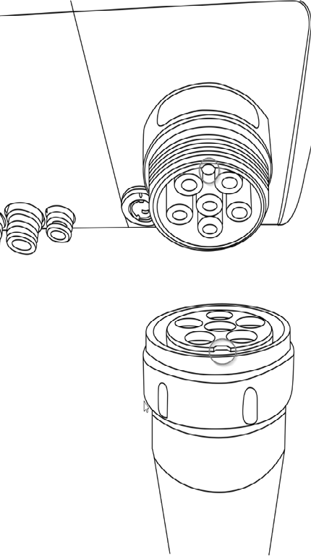

*Figure 8: Alignment key shown on Bulkhead Connector*

1. Plug in the Heater Connector cable beside the Bulkhead Connector to item 31 (figure 1), aligning the white line on the connector with corresponding white line on connector on the underside of the Internal Enclosure as in Figure 9.

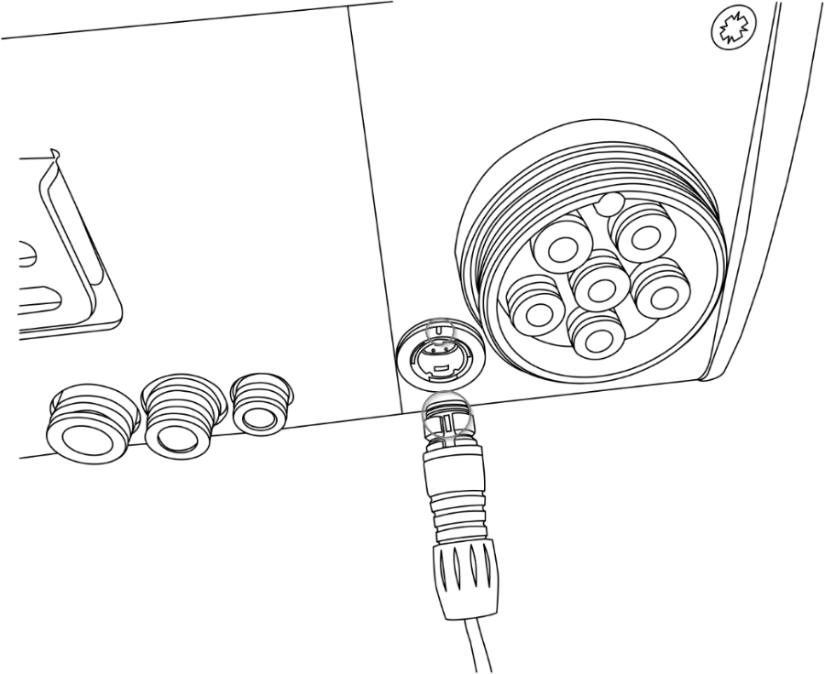

*Figure 9: Alignment markings shown on Heater Connector*

1. Fit the cable management clips between the Patient Valve Umbilical and the white spiral wrap that connects the wiring from the Control Arm to the underside of the Internal Enclosure. The Cable Management clips have a large side and a small side, the large side clips to the Patient Valve Umbilical and the smaller end clips to the white spiral wrap. The clips should be fitted approximately 250mm apart. Manipulate the Umbilical by twisting it at the black Tubing Umbilical Connector on the underside of Internal Enclosure and Spiral Wrap to ensure that they are naturally folding back towards the Acrylic Panels and are not folding out towards the bench like the picture on the left-hand side below.

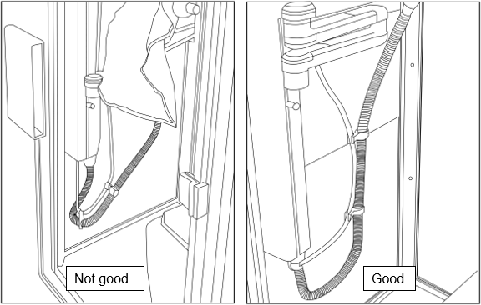

1. Connect one end of the Tubing Umbilical and the Heater Plug which is supplied in the Accessories box (figure 10) in the VitaloQUB to the underside of the External Control Module (10) to items 32 and 33 (figure 1) and connect the other end of the Tubing umbilical and Heater Plug to the back of the paired device taking note of the instructions in figure 8 and figure 9.

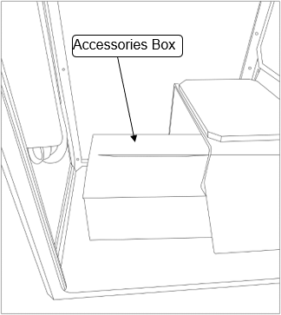

*Figure 10: Accessories Box*

1. Connect the USB Cable (supplied in Accessories Box) to item 31 (figure 1) on the underside of the External Control Module (10) and connect the other end to the back of the paired device.
2. Connect the Audio Cable (supplied in Accessories Box) to item 36 (figure 1) on the underside of the External Control Module (10) and connect the other end to the back of the main Intercom/Speaker System module (also supplied in the Accessories Box). This main Intercom/Speaker Control module must be connected to a mains power outlet using the provided power supply.
3. Connect the power supply (supplied in Accessories Box) to item 38 (figure 1) on the underside of the External Control Module (10) and then plug the mains plug into a suitable mains socket. Turn on the Main Power Switch (34) on the underside of the Control Module (10). The LED (13) on the External Control Module Door will light up to indicate power in the device.
4. Only use the VitaloQUB with the supplied medically approved low voltage power supply. Attempted use with other power sources may cause irreparable damage and invalidate the warranty. The output from the power supply is 24 volts DC.
5. To complete the setup, the paired device must be fully setup with the appropriate tubing connected for the various gases and cables connected as per their respective Instructions for Use, VitaloROV/ROV+ (09950) and VitaloLAB (09970).
6. If the device has just been unpacked or transported, ensure that it is left sitting, fully powered and is at room temperature prior to testing.

***Note:*** *The device must be turned on for 20 minutes to allow the Lilly Screen to warm up before testing, calibration, or accuracy checks are performed. Always ensure Heater Connector is connected at back of device.*

# 5. Operating Instructions

For guidance using the ComPAS2 software on the device, refer to *ComPAS2 Reference Manual (Vitalograph Morgan PFT Range)*, available in the help menu in ComPAS2 software by choosing Help > View Help.

1. On first use:
   1. Enter the correct mixtures of the test gas cylinders in the Calibration screen in ComPAS2. Then perform a gas calibration as per the on-screen instructions. Gas calibration should be performed.
   2. Perform a flow-volume span and accuracy check in the Calibration screen in ComPAS2. This should be performed daily.
   3. Perform a cabin leak test as per on screen instructions on the ComPAS2 software which will also guide you through the calibration process. It is recommended to perform a leak test on the cabin if there is any suspected damage to the door seal and it is also recommended to perform a leak test on a daily basis to ensure a leak tight cabin.
   4. Perform a mouth pressure calibration as per on screen instructions.
2. Select required subject from ComPAS2 database

*or*

Create a new subject.

1. Select required test and instruct the subject on the correct test procedure.
2. Advise the subject to enter the cabin and sit on the Bench (14) while paying attention to the step when entering the cabin. The Grab Handle (22) can be used to aid the patient into the seating position.
3. The Patient Valve Control Arm (24) must be adjusted to the correct height to ensure the Patient Valve and BVF are positioned correctly for the subject. This can be achieved by pulling the knob of Control Arm Vertical Positioning Mechanism (3) under the Patient Valve Control Arm Holder (25) outwards and then slide the Patient Valve

Control Arm (24) up or down on the linear guide rail to the required height and then release the knob and it will automatically lock into the correct position using a spring force action.

**EN**

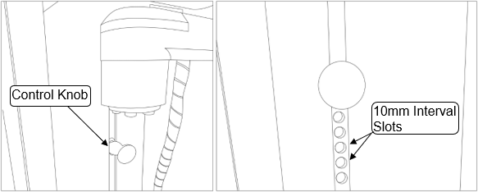

*Figure 11: Patient Valve Control Arm Vertical Positioning Mechanism*

1. The arm can be adjusted or pivoted by rotating the arm to the required position.

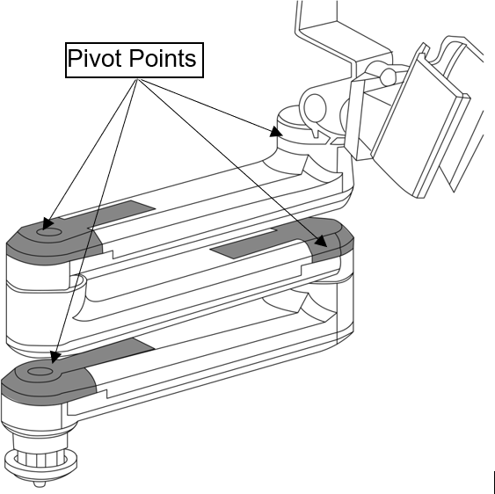

*Figure 12: Hinge Points on Patient Valve Control Arm*

1. Once the subject has been positioned correctly advise the subject that they can view the Display Monitor (20) which is located beside the Patient Valve. This can be used as an aid to guide the subject during various tests with the aid of the Dual-Way Intercom/Speaker system (21).
2. Advise the subject that if they feel uncomfortable at any stage during a test when the cabin is closed that they can press and hold the Internal Door Release Button (17) which is mounted on the Internal Enclosure (2) and which will deactivate the magnets used to keep the door closed. There is also an External Door Release Button (11) for the medical professional to use if needed and is located on the External Control Module (10) door. These Door Release Buttons are wired independently of the software so if there is a software failure these buttons can still be activated at any time. In the unlikely event of a power outage the magnets will simply de-magnetise and the door will automatically pop open which eliminates any risk to the subject getting trapped inside the cabin.

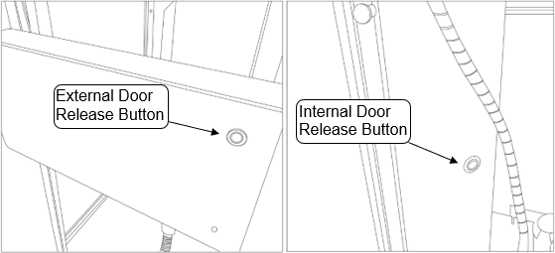

*Figure 13: Door Release Buttons*

1. Advise the subject that they can always speak to the medical professional through the Dual-Way Intercom/Speaker system (21) which for the subject is located on the Monitor Bracket (1) inside the cabin under the Display Monitor

(20). For the medical professional this shall be located beside the paired device.

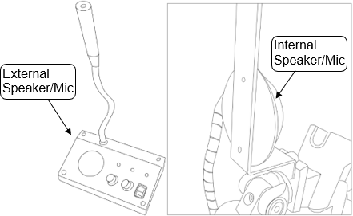

*Figure 14: Dual-Way Intercom/Speaker System*

1. Vitalograph intends that a new Bacterial Viral Filter (BVFTM) and Nose Clip be used for every subject to prevent cross contamination. Using a new BVF provides a significant level of protection of the subject, the device and the user against cross contamination during pulmonary function test manoeuvres. With the BVF fitted the Patient Valve can be left on the Patient Valve Control Arm Holder (25).
2. Once the relevant test has been completed and the door of the cabin opens by pressing “open door” on the ComPAS2 software and advise the subject that they can use the aid of the Grab Handle (22) located in front of them above the Internal Enclosure (2) to aid themselves in exiting the cabin. It is also recommended to advise the subject of the step when leaving the cabin.

## Sensor Calibration

Calibration of all pressure, flow and gas sensors is done using ComPAS2 software. For guidance, refer to the ComPAS2 Reference Manual (Vitalograph Morgan PFT Range) in the ComPAS2 software help menu by choosing Help > View Help.

## Cybersecurity Considerations

* + 1. **Specification**

The VitaloQUB has no operating system and as such will not be accessible unless it is connected to its paired device VitaoLAB or VitaloROV/ROV+. For further information in relation to cybersecurity

specifications for the VitaloLAB and VitaloROV/ROV+ please refer to their respective Instructions for

Use, VitaloROV/ROV+ (09950) and VitaloLAB (09970)

* + 1. **Interfaces**

USB: The VitaloQUB device will only communicate with compatible devices to process and display the data from such devices.

# 6. Power Management

The VitaloQUB is powered by a medically approved low voltage power supply, the combination forming a Medical Electrical (ME) System. Attempted use with other power sources may cause irreparable damage and invalidate the warranty. The output from the power supply is 24 volts DC. When the main power switch on the underside of the External Control Module (10) is turned on, a LED (13) on the External Control Module Door will light up to indicate power in the device.

To shut down the VitaloQUB device:

1. Close the ComPAS2 session on the paired device. A prompt will appear to turn off gas supply. This will automatically log-off the current user.

or

Press the power icon on log-on screen.

1. Turn off the Main Power Switch (34) on the underside of the External Control Module (10) on the VitaloQUB. The LED will turn off.
2. Turn off the Main Power Switch on the back of the paired device. The LED will turn off.

To move the paired device, ensure that the gas supplies are turned off, the gas tubing is bled free of gas and then disconnected from the “DLCO”, “O2” and “CAL” ports on the back of the device before shutdown.

**EN**

## Power Supply Information

|  |  |
| --- | --- |
| **Manufactur**er | SL Power Electronics |
| **Manufacturer Part Number** | ME150A2451N01 |
| **AC Input** | 100-240Vac |
| **Output Voltage** | 24V |
| **Output Current** | 6.05A at 100-110V  6.25A at 110-240V |
| **Output Connector** | 6 pin Molex Type |

# Cleaning & Hygiene

## Preventing Cross-Contamination of Subjects

The VitaloQUB is not designed or supplied as a ‘sterile’ device.

Vitalograph intends that a new Bacterial Viral Filter (BVFTM) be used for every subject to prevent cross contamination. Using a new BVF provides a significant level of protection of the subject, the device and the user against cross contamination during pulmonary function test manoeuvres.

The interior of a Vitalograph Patient Valve does not require decontamination where a new BVF is used for each subject. The inside and outside surfaces of the VitaloQUB device and outside of the Patient Valve, Patient Valve Tubing Sleeve and Cable Sleeves may be cleaned with a 70% isopropyl alcohol impregnated cloth to remove any visible soiling and for low level disinfection.

If you suspect the Patient Valve has become contaminated or where user risk assessment identifies a need for higher level of decontamination, then it should be cleaned by a medical professional as per the instructions on ‘Cleaning and Hygiene’ on the Vitalograph website.

## Inspection of the Vitalograph VitaloQUB

A visual inspection is recommended on a routine basis.

A visual inspection should be carried on the Door Seal to ensure there are no cracks, defects or the seal hasn’t peeled away from the glass door.

The Cyclic Pump Piston seals must be replaced on an annual basis to ensure correct operation and calibration as part of the annual service. Other parts that must be replaced on an annual basis are the Shutter Seal (Cabin Shutter Valve Assembly), and the O-Ring (Cabin Shutter Valve Assembly).

If you suspect the Lilly Screen has particulate which needs to be removed, the Patient Valve can be partly disassembled to aid cleaning as outlined in Section 7.2.1 of the VitaoLAB Instructions for Use 09970.

# Fault Finding Guide

|  |  |
| --- | --- |
| **Problem Fault Symptoms:** | * **Fails leak test** |
| Possible Causes: (In probable order) | * Ensure door is fully closed and the handle has magnetised to the magnets. This can be checked by trying to pull the door open. * Check door seal for any visible defects. * Ensure the tubing umbilical is connected correctly to the underside of the External Control Module on the VitaloQUB and also on the back of the paired device. * Ensure the shutter seal in the External Control Module is in the closed position. |
| **Problem Fault Symptoms:** | * **Display Monitor not working or not displaying correct screen** |
| Possible Causes: (In probable order) | * Ensure that the power cable is connected at the back of the Monitor and is also connected to the underside of the Internal Enclosure * Ensure HDMI Cable is connected correctly between the Monitor and the Internal Enclosure * Ensure the HDMI Cable is connected between the External Control Module and the paired device. |
| **Problem Fault Sympto**ms: | * **Intercom/Speaker not working** |
| Possible Causes: (In probable order) | * Ensure the cable from the intercom/speaker on the inside of the cabin underneath the Display Monitor is connected to the sound jack port on the underside of the Internal Enclosure. * Ensure the power cable for the Intercom that the medical professional uses is plugged in to the appropriate mains socket. * Ensure the sound jack cable is connected between the External Intercom/Speaker and the underside of the External Control Module. |
| **Problem Fault Symptoms:** | * **Flow Readings not displaying** |
| Possible Causes: (In probable order) | * Ensure the Bulkhead Connector from the Patient Valve is connected correctly to the underside of the Internal Enclsoure. * Ensure the Tubing Umbilical between the paired device and the External Control Module is connected correctly on both ends. |
| **Problem Fault Symptoms:** | * **VitaloQUB device not been recognised by ComPAS2 software on paired device** |
|  | * Ensure the USB Cable is connected from the back of the paired device to the underside of the External Control Module. * If paired with the VitaoLAB or VitaloROV/ROV+ device ensure that the USB Cable is connected from the underside of the External Control Module to the USB port on the PC connected to the VitaloLAB device. * Ensure that the second USB Cable is connected between the paired VitaoLAB device and the PC. |



## Software Version Check

To view the current version of the ComPAS2 software installed on the VitaloROV/ROV+:

* + - 1. Open the ComPAS2 software
      2. Click “help” located on the toolbar at the top of the ComPAS2 window
      3. Select “View Help”.
      4. On the homepage under the “about ComPAS2” heading the installed version is displayed in the table next to “version”

## Product Useful Life Check

The device is presumed to be in good working order if it passes the following checks/tests available in the ComPAS2 software:

* Flow Quality check
* Gas analyser Calibration
* Leak test

# Customer Service

Refer to Section 7.2 for a list of parts that must be replaced on an annual basis by the customer.

Service life of the VitaloQUB is 1 year.

The parts on which preventative inspection and maintenance shall be performed annually by Service Agents only are the Shutter Seal (Cabin Shutter Valve Assembly), O-Ring (Cabin Shutter Valve Assembly), and Cyclic Pump Piston Seals. A visual inspection shall be performed on the Pass-Through Bulkhead Connector Seal, Door Handle Screw Seals, Compensation Chamber Sealing Screws and Door Seal and replace if needed. A service manual shall detail how the preventative inspection and maintenance shall be performed.

Preventative inspection, maintenance and repairs should be carried out only by the manufacturer or by Service Agents specifically approved by Vitalograph.

For the names and addresses of approved Vitalograph Service Agents or to arrange pulmonary function test workshops, please refer to the contact information at the start of this manual.

Any serious incident that has occurred in relation to the device should be reported to Vitalograph or its Authorized Representative and the Regulatory Authorities of the country. Refer to the Vitalograph contact information at the start of this manual. This IFU is available on the Vitalograph website at the following location: www.vitalograph. com/ifu/Vitalograph_VitaloQUB_IFU.pdf

# Consumables and Accessories

The following consumables and accessories are available for use with the VitaloROV/ROV+:

|  |  |
| --- | --- |
| Cat. No. | Description |
| 28501 | Eco BVF – Bacterial/Viral Filters (100) |
| 28572 | Eco BVF and Disposable Nose Clip (80) |
| 28551 | Eco BVF with Silicone Bite-On Mouthpiece and Disposable Nose Clip (60) |
| 28554 | Eco BVF with Bite Lip (75) |
| 28553 | Eco BVF with Bite Lip and Disposable Nose Clip (75) |
| 20392 | Silicone Bite-On Mouthpiece (50) |
| 20303 | Nose Clips (200) |
| 36020 | 3 litre Precision Syringe |
| 91977 | Power Supply |
| 91342 | Lilly Screen (x5) |
| 91279 | O-rings for Patient Valve (replacements) |
| 91280 | Bag Assembly Diaphragm (replacement) |
| 91333 | Shutter Seal (replacement) |
| 91334 | Inspiratory Bag Shutter Seal (replacement) |
| 91346 | One-way Diaphragm |
| 91945 | 9L Inspiratory Bag |
| 91947 | Krytox Grease |
| 67252 | USB A to USB B Cable (to connect printer) |
| 91345 | Ethernet Cable |
| 91644 | Tubing Umbilical |
| 91985 | Dual Way Intercom/Speaker System |

# Disposal Instructions

The device must be taken to separate collection at the product end-of-life. Do not dispose of these products as unsorted municipal waste.

Accessories:

1. The 3 litre Precision Syringe should be returned to Vitalograph for disposal at the product end-of-life.
2. image001Electrical accessories must be disposed of separately according to the regulations for your country.
3. Used BVFs constitute minimally soiled waste from human healthcare and should be disposed of in line with local requirements. BVFs are made from polypropylene.
4. Remaining accessories should be disposed of using local waste disposal regulations.

# Explanation of Symbols

|  |  |
| --- | --- |
| **Symbol** | **Description** |
|  | Type BF applied Part |
|  | Class II |
| **I** | On (power) |
|  | Off (power) |
| VA | Power Rating (power supply) |
|  | Direct current (Power supply) |
|  | UL Component Recognition Mark for Canada and USA (power supply) |
|  | Certified to applicable Danish standards and requirements by UL International Demko A/S (power  supply) |
|  | United States Department of Energy Level VI (power supply) |
| **IP22** | Ingress Protection. Protection against objects greater than 12.5mm and dripping water when tilted at 15° (power supply only). |
|  | Transfer of heat in general |
| Manufacturer | USB Connector |
| IOIOI | Serial Interface |
| . | Serial Port |
|  | Computer Network |
|  | Instructions for Use; operating instructions |
|  | Refer to Instruction manual/booklet |
|  | Manufacturer |
|  | Date of Manufacture |
| Rx Only | Restricted to sale by, or on the order of a physician. |
|  | Serial number |
|  | Catalogue number |
|  | Use by date (for consumables) |
|  | Batch code (for consumables) |
|  | The device must be taken to separate collection at the product end-of-life. Do not dispose of these products as unsorted municipal waste |
|  | Fragile, handle with care |
|  | Keep Dry |
|  | Do not re-use |
|  | Non sterile |
|  | Recycle |
|  | QR code - matrix bar code. All information in the bar code is included in the text under it. |
| **PC/ABS** | Polycarbonate/Acrylonite Buradiene Styrene |
|  | Sound Port |
|  | MIC |
|  | HDMI |
|  | Medical Device |
|  | MR Unsafe – Do not use this device in an MRI environment |
|  | Country of Manufacture |
|  | UKCA Class IIa 756776 |
|  | CE mark 2797 |

# Description of the VitaloQUB

**EN**

The VitaloQUB, is a pulmonary function testing system designed for use in a variety of professional healthcare environments e.g., primary care, hospitals, and pharmaceutical research centres.

The VitaloQUB is a sealed cubicle where a patient sits for the purpose of performing VTG and Airways Resistance testing. The VitaloQUB is operated as a system when paired with the VitaloLAB or VitaloROV/ROV+ device and is controlled by the ComPAS2 software. The system measures the changes in thoracic volume that accompany a compression or decompression of the gas in the lungs during respiratory manoeuvres by measuring the changes in pressure within a constant-volume chamber (variable pressure plethysmograph). The patient is guided through the required breathing actions by a medical professional with the assistance of a Monitor and Dual-way Intercom/Speaker system.

The same Patient Valve as used in the VitaloLAB and VitaloROV/ROV+ devices is used in the VitaloQUB device but is now located inside the cabin. This allows the VitaloQUB system to measure dynamic lung volumes, ie spirometry, gas diffusion, lung volumes by various techniques and other respiratory measurements.

The patient would normally sit inside the cubicle, with the door closed to provide a controlled environment for plethysmograph testing. A wheelchair bound patient can have some of the tests carried out whilst still in their wheelchair by using the Patient Valve rotated out of the cabin door using the adjustable Patient Valve Control arm. Pulmonary function testing is a valuable tool that provides important information to clinicians which is used together with other physical findings, symptoms, and history to reach a diagnosis. Pulmonary function testing may support or exclude diagnosis, but it cannot make one.

The devices are intended for use by medical professionals trained in respiratory and lung function testing only and are not designed to be operated by the subject in any way. Apart from the instruction manual, there are no other training requirements for the medical professional.

This Instructions for Use relates to the hardware of the VitaloQUB only. For guidance on using ComPAS2 software refer to the ComPAS2 Reference Manual (Vitalograph Morgan PFT Range), available in the help menu in ComPAS2 software by choosing Help > View Help.

Tests measured by the VitaloQUB include:

|  |  |
| --- | --- |
| **Abbreviation** | **Test** |
| VTG | Volume of Throacic Gas |
| RAW | Airway Resistance |

Other tests that are selectable or measurable on the VitaloQUB in conjunction with the paired device VitaloROV/ROV+ or

VitaloLAB are as follows can be seen in their respective IFU’s 09950 & 09970.

# Technical Specifications

|  |  |
| --- | --- |
| Products | Model 9160 Vitalograph - VitaloQUB |
| Model | 9160 |
| Essential Performance | The essential performance of the Plethysmograph device is to form a seal within the patient cabin both in normal and single fault conditions, so that VTG and Airways Resistance can be measured. |
| Essential Performance Test Limits | Pressurization target: 0.33cmH2O  Leak Target: 0.10 cmH2O between 4-11 seconds. |
| Flow detection principle | Heated Lilly type pneumotachograph |
| Back pressure | Less than 0.15kPa/L/second @ 14L/s, complies with ISO26782:2009 |
| Volume detection | Flow integration sampling @ 100Hz |
| Volume accuracy | Within ±2.5% or ±75 mL |
| Voltage/Frequency | 24-240V; approximately 50/60 Hz |
| Flow accuracy | Within ±2% over the range of -14 to +14 L/s |
| Flow Measurement Range | Max. flow rate ±14 L/s  Min. flow rate ±0.2 L/s |
| Operating temperature range | ISO26782 limits: 17–37ºC |
|  |
| Design limits: 15–32ºC |
| Operating humidity range | 30%–75% |
| Ambient pressure range | 850hPa–1060hPa |
| Shutter Valve | Pneumatic spring-return cylinder |
| Service Life | The recommended service life is 1 year |
| Product Life | 10years+ when maintenance and servicing (1 year service life) procedures are adhered to. |
| Performance standards the VitaloQUB meets or exceeds | ISO 23747:2015, ISO 26782:2009, ATS/ERS: 2019 |
| Safety standards | EN 60601-1:2006+A1:2013+A2:2021 |
| EMC standards | EN 60601-1-2:2015+A1:2021 |
| QA/GMP standards | EN ISO 13485 |
| Size | 970 mm x 750 mm x 1750 mm |
| Net Weight | 203 kg |
| Communications | 1 x USB, 1 x HDMI Port, 1 x Audio Jack, |
| Software | Morgan Scientific ComPAS2 Reference Manual (Vitalograph Morgan PFT  Range) |
| Communications | 1 x USB, 1 x HDMI Port, 1 x Audio Jack, |
| Software | Morgan Scientific ComPAS2 Reference Manual (Vitalograph Morgan PFT  Range) |
| 510(k): K213872 |
| *Notes:* | |
| * *The specified operating temperature and humidity ranges apply to the device plus accessories.* * *The Patient Valve is a type BF applied part. The device body or other accessories are not applied parts. An applied part is a part of the equipment that in normal use necessarily comes into physical contact with the subject for the equipment or system to perform its function.* * *Vitalograph will make available any information necessary to assist Service Agents to repair parts, such as circuit diagrams, part lists, descriptions, calibration instructions or other information.* | |

# Electromagnetic Compatibility (EMC) Standards

Marking by the symbol  indicates compliance of the 9160 VitaloQUB to the European Medical Device Regulation 2017/745 (EU MDR) as amended.

The Vitalograph - VitaloQUB is intended for use in primary care, hospitals, and pharmaceutical research centres, except for near active high frequency surgical equipment and the RF shielded room of an ME system for magnetic resonance imaging, where the intensity of electromagnetic disturbance is high. The customer or the user of the Vitalograph – VitaloQUB should assure that it is used in such an environment.

The 9160 Vitalograph - VitaloQUB was tested in accordance with:

EN 60601-1:2006 + A1:2013 + A2:2021 - Medical electrical equipment – Part 1: General requirements for basic safety and essential performance

EN 60601-1-2:2015+A1:2021 - Medical electrical equipment - Part 1-2: General requirements for basic safety and essential performance - Collateral Standard: Electromagnetic disturbances - Requirements and tests.

|  |  |  |
| --- | --- | --- |
| **EN 60601-1-2:2015 + A1:2021 - Emissions tests** | | |
| **Emissions test** | **Compliance** | **Electromagnetic environment - guidance** |
| RF emissions CISPR 11 | Group 1 | The Model 9160 uses RF energy only for its internal function. Therefore, its RF emissions are very low and are not likely to cause any interference in nearby electronic equipment |
| Radiated and Conducted Emissions CISPR 11  Harmonic Emissions IEC 61000-3-2  Voltage fluctuations/ flicker emissions  IEC 61000-3-3 | Class A | The Model 9160 is suitable for use in for non-residential/professional environments such as hospitals. If used in residential environment this equipment might not offer adequate protection to radio-frequency  communication services. The user might need to take mitigation measures,  such as relocating or re-orienting the equipment. |

|  |  |  |
| --- | --- | --- |
| **EN 60601-1-2:2015 + A1:2021 - Immunity tests** | | |
| **Immunity test** | **Test level** | **Compliance level Reached** |
| Electrostatic discharge (ESD) EN 61000- 4-2 | ± 8 kV contact  ± 2, ±4, ±8 and ±15 kV air | ± 8 kV contact  ± 2, ±4, ±8 and ±15 kV air |
| Proximity fields from RF wireless communications equipment  EN 61000-4-3 | 9 to 28V/m  385 to 5785MHz  As per Table 9 EN60601-1-2 | 9 to 28V/m  385 to 5785MHz  As per Table 9 EN60601-1-2 |
| Radiated RF EN 61000-4-3 | 3 V/m (professional healthcare)  80 MHz to 2.7 GHz  80 % amplitude modulated at 1 kHz | 3 V/m (professional healthcare)  80 MHz to 2.7 GHz  80 % amplitude modulated at 1 kHz |
| Electrical fast transient/burst Immunity EN 61000-4-4 | ±2kV for power supply lines | ±2kV for power supply lines |
| Surge Immunity EN 61000-4-5 | ±1kV differential mode  Device is identified as Class II unearthed equipment therefore common mode testing is not required | ±1kV differential mode  Device is identified as Class II unearthed equipment therefore common mode testing is not required |
| Conducted RF Immunity EN 61000-4-6 | 3V/m 0.15-80MHz  6V/m ISM/amateur radios bands  0.15-80MHz  80% AM at 1kHz | 3V/m 0.15-80MHz  6V/m ISM/amateur radios bands  0.15-80MHz  80% AM at 1kHz |
| Power frequency (50/60 Hz) magnetic field Immunity  EN 61000-4-8 | 30 A/m; 60 Hz | 30 A/m; 60 Hz |
| Voltage dips, short interruptions and voltage variations on power supply input lines  EN 61000-4-11 | 100% drop, 0.5 cycles, 0o, 45o, 90o, 135o, 180o, 225o, 270o, 315o  100% dip, 1 cycle  30% dips, 25/30 cycles | 100% drop, 0.5 cycles, 0o, 45o, 90o, 135o, 180o, 225o, 270o, 315o  100% dip, 1 cycle  30% dips, 25/30 cycles |
| Proximity magnetic Fields EN 61000-4-39 | 8A/m 30kHz 65A/m 134.2kHz (2.1 kHz PM)  7.5A/m 13.56MHz (50 kHz PM) | 8A/m 30kHz 65A/m 134.2 kHz (2.1 kHz PM)  7.5A/m 13.56 MHz (50 kHz PM) |

Medical Devices may be affected by mobile RF communications equipment including cellular telephones and other personal or household devices not intended for medical facilities. It is recommended that all equipment used near the Vitalograph product comply with the medical electromagnetic compatibility standard and to check before use that no interference is evident or possible. If interference is suspected or possible, switching off the offending device is the normal solution, as is required in aircraft and medical facilities.

Medical electrical equipment needs special precautions regarding EMC and needs to be installed and put into service according to the EMC information provided.

**NOTE:** The EMISSIONS characteristics of this equipment make it suitable for use in industrial areas and hospitals (CISPR 11 class A). If used in a residential environment (for which CISPR 11 class B is normally required) this equipment might not offer adequate protection to radio-frequency communication services. The user might need to take mitigation measures, such as relocating or re-orienting the equipment.

**WARNING: No modification of this equipment is allowed.**

# FDA Notice

**Caution: Federal Law restricts this device to sale by, or on the order of a physician.**

# 17. Regulatory Information- EU Declaration of Conformity

|  |
| --- |
| **Product: 9160 Vitalograph - VitaloQUB**  Vitalograph hereby ensures and declares that the above product associated with these instructions for use, is designed and manufactured in accordance with the following QMS regulations and standards:   * European Medical Device Regulation (MDR) 2017/745, as amended.   This device is classified as IIa per Annex IX of the MDR also meets the provisions of the General Safety and Performance Requirements, Annex I, via compliance with Annex IV of the Medical Devices Regulation as per Article 52.   * EN ISO 13485 Medical devices. Quality management systems. Requirements for regulatory purposes.   Certifying body: British Standards Institute (BSI)  BSI Notified Body number: 2797  Certificate number: 772430  Signed on behalf of Vitalograph (Ireland) Ltd. |
|  |
|  |
| Frank Keane  CEO, Vitalograph Ltd. |

# 18. Regulatory Information- UKCA

Product 9100 Vitalograph VitaloLAB

Vitalograph hereby ensures and declares that the above product associated with these instructions for use, is designed and manufactured in accordance with the following QMS regulations and standards:

•UK Medical Device Regulation 2002, as amended. This device is classified as IIa per EU Directive 93/42 Annex IX, and meets UK MDR 2002 Part II (7), as amended. Devices IIa comply with Annex II, Art 11.

•BS EN ISO 13485 Medical Devices. Quality Management Systems Requirements for Regulatory purposes.

**

Certifying Body: British Standards Institute (BSI).

BSI Conformity Assessment Body #: 0086

Certificate No: UKCA 756776

# Guarantee

Subject to the conditions listed below, Vitalograph Ltd. and its associated companies, (hereinafter called the Company) guarantee to repair or at its option replace any component thereof, which, in the opinion of the Company is faulty or below standard as a result of inferior workmanship or materials.

The conditions of this Guarantee are:

1. This Guarantee shall only apply to hardware defects which are notified to the Company or to its accredited distributor within 2 years of the date of purchase of the equipment, unless otherwise agreed in writing by the Company.
2. Software (meaning computer software, or user installable modules) is guaranteed for 2 years from the date of purchase.
3. The Company warrants that the software when correctly used in conjunction with the hardware will perform in the manner described in the Company’s literature and user manuals. The Company undertakes to rectify at no expense to the customer any software failure notified within the period stated above, provided that the failure can be recreated, and the software has been installed and used in accordance with the user manual. Notwithstanding this clause, the software is not warranted to be free of errors.
4. This Guarantee does not cover any faults caused by accident, misuse, neglect, tampering with the equipment, use of consumable items or parts not approved by the Company, or any attempt at adjustment or repair other than by personnel accredited by the Company, nor does it cover reinstatement of any configuration changes caused by the installation of any software.
5. If a defect occurs, please contact the supplier from it was purchased for advice. The Company does not authorize any person to create for it any other obligation or liability in connection with Vitalograph® equipment.
6. This Guarantee is not transferable, and no person, firm or company has any authority to vary the terms or conditions of this guarantee.
7. To the maximum extent permitted by law, the Company does not accept liability for any consequential damages arising out of the use of, or inability to use any Vitalograph® equipment.
8. This Guarantee is offered as an additional benefit to the Consumer’s statutory rights and does not affect these rights in any way.