
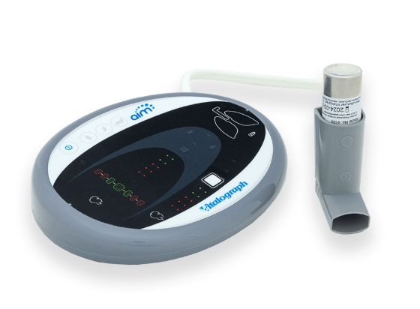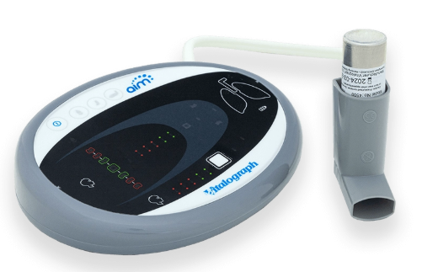
Vitalograph AIM™ (Aerosol Inhalation Monitor)

The Vitalograph AIM™ (Aerosol Inhalation Monitor) is designed to assist medical practitioners in training patients to use their inhaler correctly.

Technical Specifications

Product | Vitalograph AIM (Aerosol Inhalation Monitor)
Model | 4500
Flow Detection Principal | Differential Pressure Sensor
Flow Detection | Flow sampling @ 20Hz
Maximum Flow | 100L/min
Flow Impedance of Inhaler Simulator Mouthpiece | DPI: 0.49 cmH2O/L/min at 50 L/min.  MDI & Spacer: 0.016 cmH2O/L/min at 50 L/min
Flow Accuracy when Operated in Operating Temperature Range Conditions | Better than ±5% or 5L/min
Operating Temperature Range | Design limits: 10–40ºC
Safety Standards | EN ISO 60601
Power Supply | 4 x AAA 1.5V Batteries
Battery Life | 1 year when using one session per day, with three tests per session, and an average of five sessions per week
Dimensions | 165mm (length) x 133mm (width) x 39.6mm (height)
Weight | 260g (incl. batteries and tubing)


063170_1
vitalograph.com

